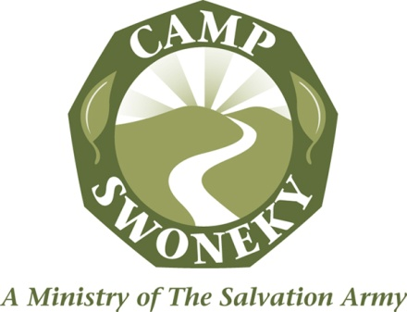
Housekeeping/Laundress

Qualifications: Preferably 15 years of age or older.

Willingness to serve campers and staff by providing clean facilities.

Responsible to: Assistant Camp Director and Housekeeping Supervisor

Objective: To maintain all assigned areas in a manner that
presents a constant image of cleanliness, order,
and high health/hygienic standards.

Responsible for: Laundry
Keeping the laundry room neat and clean at all times (including appliances).

Daily clean lint trap on dryer (this is a fire hazard!)

Preparing and counting linens for cabin use each week.

Laundering of liens at the end of each camp session.

Washing, drying and organizing lost and found at the end of each week.

Daily laundering of staff clothing (based on daily laundry schedule).

Laundering “friendly camper &”neosa” laundry, if the
Need arises.

Laundering all mop heads from cabins as dropped off.

Keeping track of supplies, notifying your supervisor of items needed.

Housekeeping
Responsible for maintaining overall cleanliness of
the camp as follows:

Cabin Supplies: Assisting in replenishing of supplies for cabins as needed.

Camp Office: Sweeping, mopping and emptying trash cans. Cleaning bathroom and restocking paper goods

Chamberlain Hall: Cleaning restrooms and checking supplies (morning and afternoon).

Swoneky Lodge/ Conference Center: Cleaning as directed.

Rec Hall: Cleaning restrooms and keeping supplied with paper goods.

Bath House: Cleaning sinks, toilets, mirrors, and showers daily. Keeping supplied with paper goods. Sweeping and mopping daily.

Dining Hall: Clean Bathrooms and restock daily

Maintenance shop: Clean Bathroom and restock

Summary: Restroom cleaning generally includes keeping supplied with toilet paper, paper towels, soap, etc… Cleaning toilets, floors, sinks, mirrors, etc… daily. Restrooms must always be spotless!

All staff may be called upon at any time to assist in the total operation of the camp and are expected to be involved fully in the total camp program. Exceptions/absences are excused only through the Camp Director or Assistant Camp Director.

THE SALVATION ARMY MISSION STATEMENT:
The Salvation Army, an international movement, is an evangelical part of the universal Christian Church. Its message is based on the Bible. Its ministry is motivated by the love of God. Its mission is to preach the gospel of Jesus Christ and to meet human needs on His name without discrimination.

ACKNOWLEDGEMENTS OF RELIGIOUS PURPOSES OF THE SALVATION ARMY:
The employee acknowledges that he/she has been informed and understands The Salvation Army’s religious purpose and status as a church. The employee agrees that he/she shall do nothing in his/her relationship with The Salvation Army as an employee to undermine its religious mission. The employee agrees and understands that his/her work-related conduct must not conflict with, interfere with, or undermine such religious programs or The Salvation Army.

Updated November 7, 2018

